**Javascript Assignment 1 ( 04/01/2022 )**

**P1:- Return true if given variable is divisible by 5 else return 5**

**var x;**

**x = 25;**

**//x = 24;**

**if (x % 5 == 0) {**

**console.log("True");**

**} else {**

**console.log(x + " " + "not divisible by 5");**

**}**

**Output**

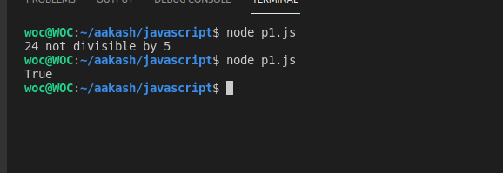

**P2:- Return True if given variable is string else return False**

**var a1;**

**a1 = "aakash";**

**//a1 = 1234;**

**if (typeof a1 === "string") {**

**console.log("True");**

**} else {**

**console.log("False");**

**}**

**Output**

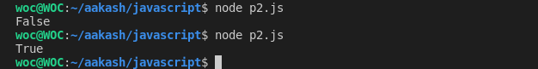

**P3:- Return True if given variable is float else return False**

**var n;**

**n = 12.4;**

**//n = 1234;**

**if (n % 1 !== 0) {**

**console.log(n + " Enter value is float");**

**} else {**

**console.log(n + " Enter value is not float");**

**}**

**Output**

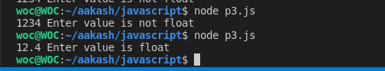

**P4:- Build a calculator**

**var cal, n1, n2, ans = 0;**

**n1 = 20;**

**n2 = 5;**

**cal = "-"**

**//cal = "+"**

**//cal = "*"**

**//cal = "/"**

**if (cal == "+") {**

**ans = n1 + n2;**

**console.log("Add:" + ans);**

**} else if (cal == "-") {**

**ans = n1 - n2;**

**console.log("sub:" + ans);**

**} else if (cal == "*") {**

**ans = n1 * n2;**

**console.log("Mul:" + ans);**

**} else if (cal == "/") {**

**ans = n1 / n2;**

**console.log("Div:" + ans);**

**} else {**

**console.log("enter only number");**

**}**

**Output**



**P5:- Find Minimum element from 2 elements**

**var n1, n2;**

**n1 = 100;**

**n2 = 30;**

**if (n1 < n2) {**

**console.log(n1 + " is minimum element");**

**} else {**

**console.log(n2 + " is minimum element")**

**}**

**Output:**



**P6:- Return True if element 1 is divisible 2 and vice versa else False**

**var n1, n2;**

**n1 = 15;**

**n2 = 5;**

**if (n1 % n2 == 0 && n2 % n1 == 0) {**

**console.log("True");**

**} else {**

**console.log("False")**

**}**

**Output:**

